 **3 Apr 2015** **The Weekly Bulletin of Rotary Club of Kathmandu Mid-Town** **bc-38/4.015**

|  |
| --- |
|  |

District: 3292 Web:www.rotarymidtown.org.np Club Id: 26776

**APRIL IS THE MAGAZINE MONTH**

**Why Magazine Month?**

Club’s Weekly Meeting # 1272 on Friday, 27 March:

Extracts of the Minutes :



“1. The meeting #1272 was called to order at 8:00 AM by Acting President

PP Saroj.

“3. PP Saroj welcomed members and visiting Rotarians (Peter Reid (UK),

David Sowerwein(USA), Rajendra Bhadur Shrestha(Washington DC) and

Rtn Jessica Huang(Palo Alto, Calif) and guests (Bill Moore (CAN),

Malcolm Snead(UK), Nicola Hinds(UK) and Charlotte Warren (Bali and

Swizerland).

“7. Our speakers Malcolm Shead and Nicola Hinds were introduced by

visiting Rotarian Peter Reid. ShelterBox provides emergency shelter and

vital supplies to support communities around the world overwhelmed by

disaster and humanitarian crisis. The global support from the Rotary

network is the cornerstone that ShelterBox is built on.

See <http://www.shelterbox.org/> If there are families in need of emergency shelter, ShelterBox does everything it can to help them rebuild their lives. Malcolm works at ShelterBox HQ in Cornwall, in D1290, and Gopal visited there when he led the GSE team in 2009.  Nicola is a volunteer who travels with ShelterBoxes and both of them were in Nepal to evaluate the 2014 deployments for landslide (Sindhupalchok) and floods (Surkhet, Bardiya and Salyan).  They gave an impressive presentation and club members showed real appreciation, both in the meeting and in conversations afterwards.. They told that through the time that different teams from ShelterBox were here they were supported by a Rotaract member, Jitendra Singh.  He started by translating for team members, then travelled with them to every district they went to, and in the end he knew as much about ShelterBox as any of their trained representatives. He gave up a full ten weeks of his life for this, and when they said goodbye to him last Thursday he spoke emotionally about his time - 'ShelterBox has changed me'. PP William gave the vote of thanks.

”8. Information sharing:

> Reminder: Mid-Town Pot Luck Dinner tomorrow March 28, 2015 at the home of Rtn Sheri (adjacent to the British School in Kupondole).

> Mid-Town is sponsoring 2 Rotaracts to attend the Rotary Youth Leadership Awards (RYLA) 30 March-2 April;

develops leadership 18-23 year olds. We will be inviting them to share short highlights from their RYLA experience in

coming weeks.

> Reminder: Preparations for the RI Convention in Rio – early registration ends March 31 – sign up now – last week's Minutes contain visa application information.

> All Mid-Towners invited to PE Paras' son's 'bhartaman' celebration on April 6 (1-1:30PM) at Panchyan (150m from Norvic Hospital).

> PP RR updated on last week's visit to Sindupulchowk to visit the First Steps Himalaya project. Mid-Towners who

attended were duly impressed with the Rotary-funded teacher training that is taking place there.

> PP Komal updated on the presentation last Tuesday by Rtn Bibhek Pradhan who made great efforts to help the

Bhaktapur Cancer Hospital during its early days.

> PP CK Golchha reminded that the A&M project is winding down. It would be nice to have a group visit to see the new

birthing beds. The date for the visit is 11 April – please contact PP CK if you are interested in attending.

> Visiting Rotarian Jessica Huang said that people can register to donate and save lives at <http://nepalskinbank.org>.

We have a new Facebook page at http://facebook.com/nepalskinbank, where we will be adding more content for

people to learn about skin donation and get their questions answered. Rotary club members are also invited to our

Skin Bank Champions Celebration on Saturday 3/28 (tomorrow) from 1-2pm in Kirtipur Hospital. We will provide some

refreshments and a lot of information about the burn hospital and skin bank..

“9. Statistics of the meeting: Members present: 22”

# Weekly Meetings and Programs :

|  |  |  |
| --- | --- | --- |
| Date | Program/ Speaker | Topic of Presentation |
| 3 April | Kanak Dixit | What Next ? |
|  |  |  |

Weekly Meeting on Friday, 3 April:

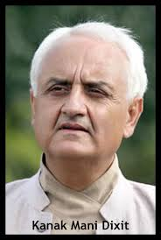

Mr Kanak Dixit will be our guest speaker. He will give a talk on the topic 'What Next'?

The journalist, writer and civil rights activist Kanak Mani Dixit is Founding editor of the Himal

Southasian regional review magazine, as well as publisher of the Nepali language weekly

Himal Khabarpatrika. He has degrees in Law (Delhi University), International Relations and

Journalism (Columbia University). He has been a journalist since 1971, and worked in the

United Nations Secretariat between 1982 and 1990. Lately, he has been engaged in civil

rights activism in relation to peace, democracy and human rights in Nepal

Himal Southasian was begun as a Himalayan magazine in 1987 and transformed into a

Southasian periodical in 1996. Since then, through the pages of the magazine, Dixit has been

engaged in the quest to define the Southasian space and identity. He is also a political

commentator on Nepal affairs, in the Nepali language dailies, in Himal Khabarpatrika, The

Nepali Times and (as a columnist) The Kathmandu Post.

Beyond journalism, Dixit is linked to the Film Southasia festival of documentaries, Spinal Injury

Sangha-Nepal, Shikshyak magazine for Nepal's school teachers, and the Jagadamba printing press.

Dixit is translator of Bishweshwor Prasad Koirala's Atmabrittanta: Late Life Reflections and is a children's author, including of the much-translated work, The Adventures of a Nepali Frog and the more recent Every Which Way up Everest. Having contributed to several Southasian anthologies, he is also author of two works of political commentary, Dekheko Muluk ('The Country I See', Jagadamba Prakashan) and Peace Politics of Nepal (Himal Books).

Some of Dixit's writings are archived at [www.kanakmanidixit.com](http://www.kanakmanidixit.com)

**Mid-Towners’ Potluck on Saturday, 28 March 2015**

Mid-Towners had a wonderful evening during their Potluck dinner on Saturday, 28 March, at Rtn Sheri’s house, adjacent to the British School in Kopundole, Lalitpur. There were fellowships among Rotarians, family members, and friends. Rtn Mani Joshi had his Birthday Cake cutting ceremony right there amidst ‘A Happy Birthday’ chant. There were varieties of food, lots of sweets, and lots of soft and hard drinks as well. The ‘crowd’ could not finish up the ‘left-over’ drinks, obviously for “MaPaSe” reason. And of course, there were lots of fun during ‘raffle’ drawings.

Those who could not make it missed indeed a lot of fun.

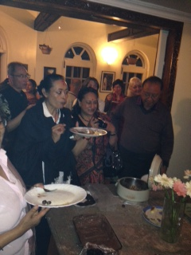 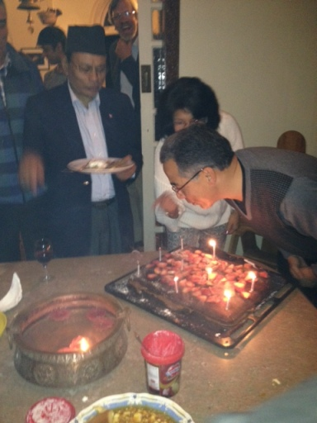 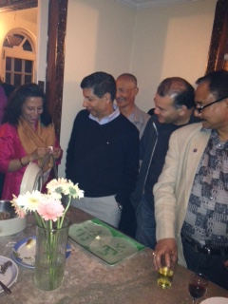 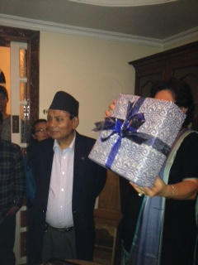

**Passengers get out, push frozen Siberian plane!**

Have you ever had an experience of pushing aeroplane?

Siberian air passengers had to get out and push their plane in temperatures of minus 52 degrees Celsius after its chassis froze. The story emerged after a passenger posted a video on YouTube showing a group of cheery travelers pushing the Tupolev plane on the snow-covered runway in Igarka, which is beyong the Arctic Circle. “Due to the low air temperatures, the chassis’s brake system froze and a tow truck was unable to move the plane onto the taxiway to carry out the flight,” transport prosecutors in western Siberia confirmed in a statement.

The plane with 74 passengers on board was being operated by Katekavia, a Siberian airline, a part of UTair group.

It was flying from ‘Igarka’, around 2,800 km northeast of Moscow, to the Siberian city of Krasnoyarsk. “‘The plane had been there for 24 hrs and the pilots forgot to take off the parking brake. That caused the brake pads to freeze up.”

*Source: The Himalayan Times*

**Every Day Is World Water Day With Rotary !**

At least 3,000 children die each day from diarrheal diseases caused by unsafe water, a grim reminder for Rotary members who make providing clean water and sanitation an organizational priority. While very few people die of thirst, millions die from preventable waterborne diseases, providing the impetus for our members to provide toilets and latrines and other clean water initiatives in underdeveloped countries. Members also teach these communities to maintain new infrastructure, and organize educational projects to promote hand-washing and other good hygiene habits.

Though 22 March is recognized as World Water Day, our commitment to these causes is ongoing. In Ghana  Rotary member Samuel Obour spearheads projects to install latrines, washing stations, and toilets across Ghana. In Latin America, youth from Connecticut, USA, lay water pipelines for communities for high altitude villages. Dozens of other water projects await financial support, from water harvesting in Mexico to a well for clean potable water in Egypt.

In Sao Paulo on 4 June there will be World Water Summit, the seventh time Rotary members have hosted NGOs, nonprofits, businesses, and concerned citizens of the world for learning, networking, and discussion around clean water. In addition to our summit, members regularly host water experts for roundtable discussions at their clubs.

*Source: RI News*

Travel / Tourism

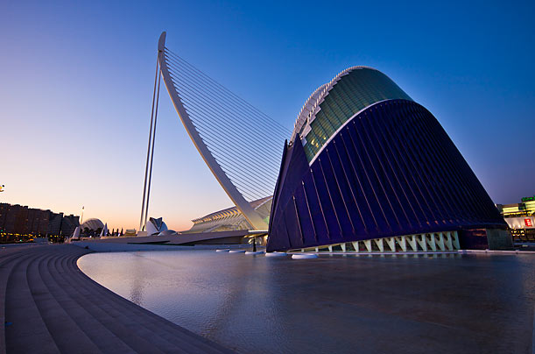

“The World is a book, and those who do not travel read only a page.”





**A THOUGHT FOR TODAY:**

**[“Any fool can criticize, condemn and complain – and most fools do.](http://www.brainyquote.com/quotes/quotes/b/baruchspin101666.html" \o "view quote)**

**[But it takes character and self-control to be understanding and forgiving.](http://www.brainyquote.com/quotes/quotes/b/baruchspin101666.html" \o "view quote)**

*[- Dale Carnegie](http://www.brainyquote.com/quotes/quotes/b/baruchspin101666.html" \o "view quote)*

On Lighter Side:



**Don't worry about old age: it doesn't last that long.**



All of you are going to be busy people next year, and I urge you to make a habit of asking

other busy people to join Rotary. Don't leave them out. Maybe some of them will say no,

and that's OK. But I don't want any of them to say they are not Rotarians because nobody

ever asked.

**RI President GARY C.K. HUANG**

## 3 April 2015 The Weekly Bulletin of Rotary Club of Kathmandu Mid-Town bc-38/3.015

******************************************